USER MANUAL
Index:
- Sign-up and Log-in
  - Logging in
  - Register
  - Dashboard
  - Log out
- Profile Management
  - View Profile Information
  - Edit Profile Information
  - Updating your profile
  - Deleting your profile
- Puzzles
  - Accessing the puzzle page
  - Choosing a puzzle
  - Playing a puzzle
- Adaptive and Learning Paths
- XP and Levels
5.1. Default Xp and Level
5.2. XP Increase
5.3. Level Increase
- Save and Load Progress
6.1 Accessing Games completed
6.2 Completed games table before playing puzzles
6.3 Completed games table after playing puzzles
- Start and completion time
7.1 Accessing time completion table
7.2 Viewing time completion table
- Leaderboard
8.1 Accessing Leaderboard Page
8.2 Leaderboard with one user
8.3 Leaderboard with more than one user
- Search And Filter
9.1 Search Bar
9.2 Dropdown Feature

- Achievements
10.1 Accessing Achievements Page
10.2 Viewing the Achievements table

- Change Languages
11.1 Accessing Languages Dropbox
11.2 Dropdown Feature

- Daily Streak
12.1 View Daily Streak
12.2 Claim XP
12.3 Return to Welcome Page

- Sign Up and Log In
  - How To:
1.1) Log In: The first page you'll be greeted with is the “Login” page.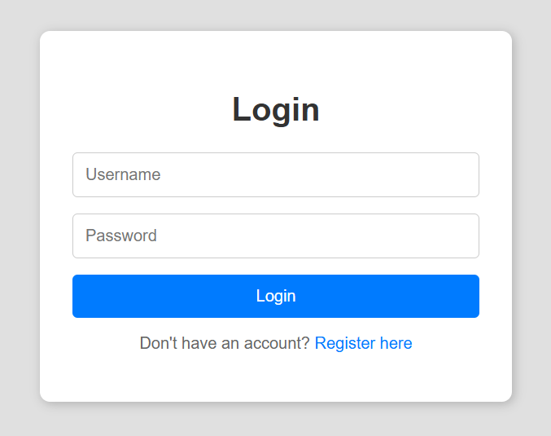

1.2) Register: Users with no previous accounts can be redirected to the ”Register” page.
Where an account can be made through a username and password.
Once the registration is successful we can log in those details
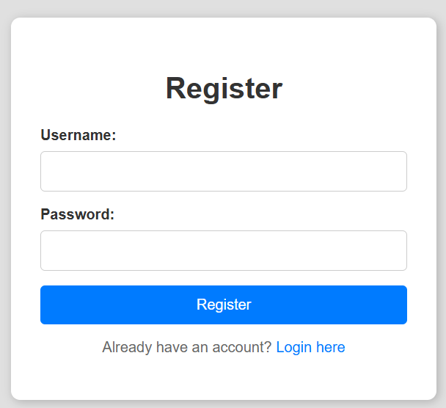

1.3) Dashboard: After the user successfully logs in to their account, the dashboard will open where multiple boxes can be accessed.
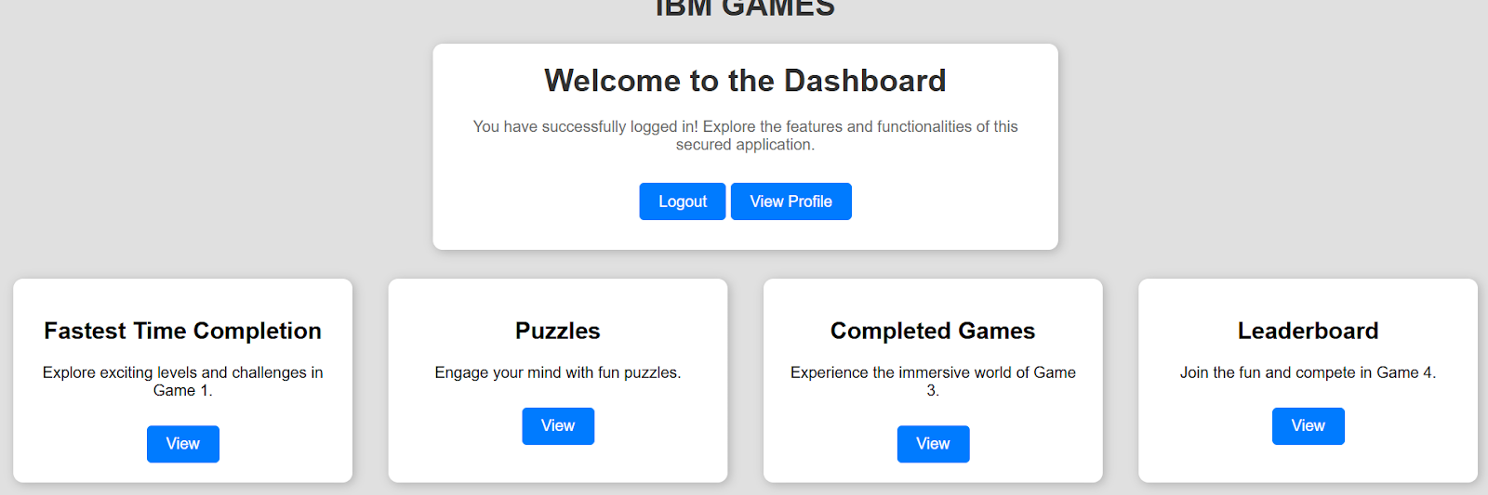
1.4) Log Out: The user may decide that they want to log out their account, this can be achieved through the “LogOut” button. They will be redirected to the “Log In” page.

- Profile Management
- How To:
2.1) View Profile Information: From the dashboard, click the “View Profile” Button.
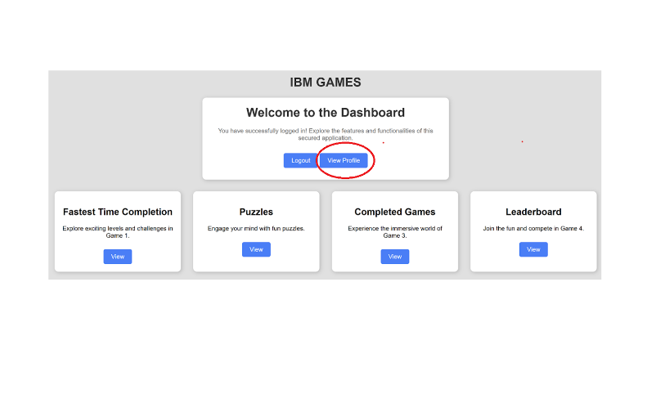
2.2) Edit Profile Information:

You will then be taken to the profile page where you can edit your details. Click “Edit Profile” to do so.
Otherwise you can return to the homepage through the “Return to dashboard Button”.
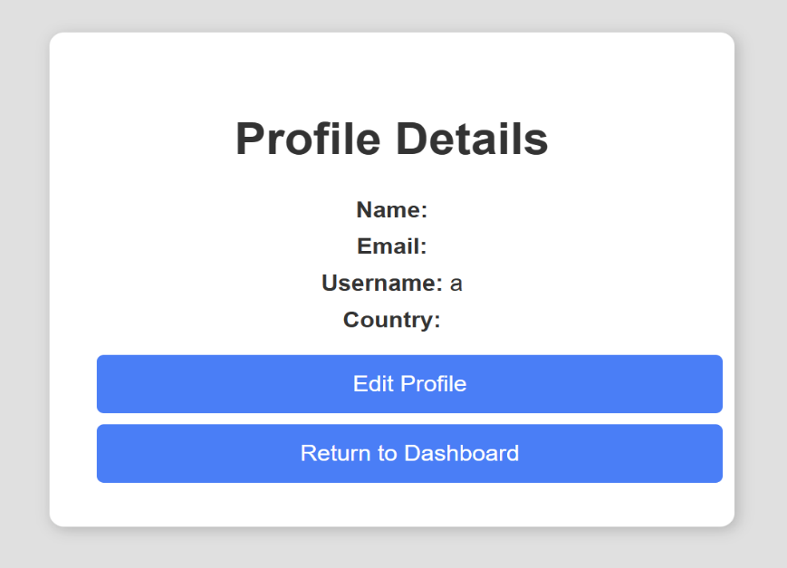
2.3) Updating your profile:
After clicking the “Edit Profile” button. You can now edit your profile details.
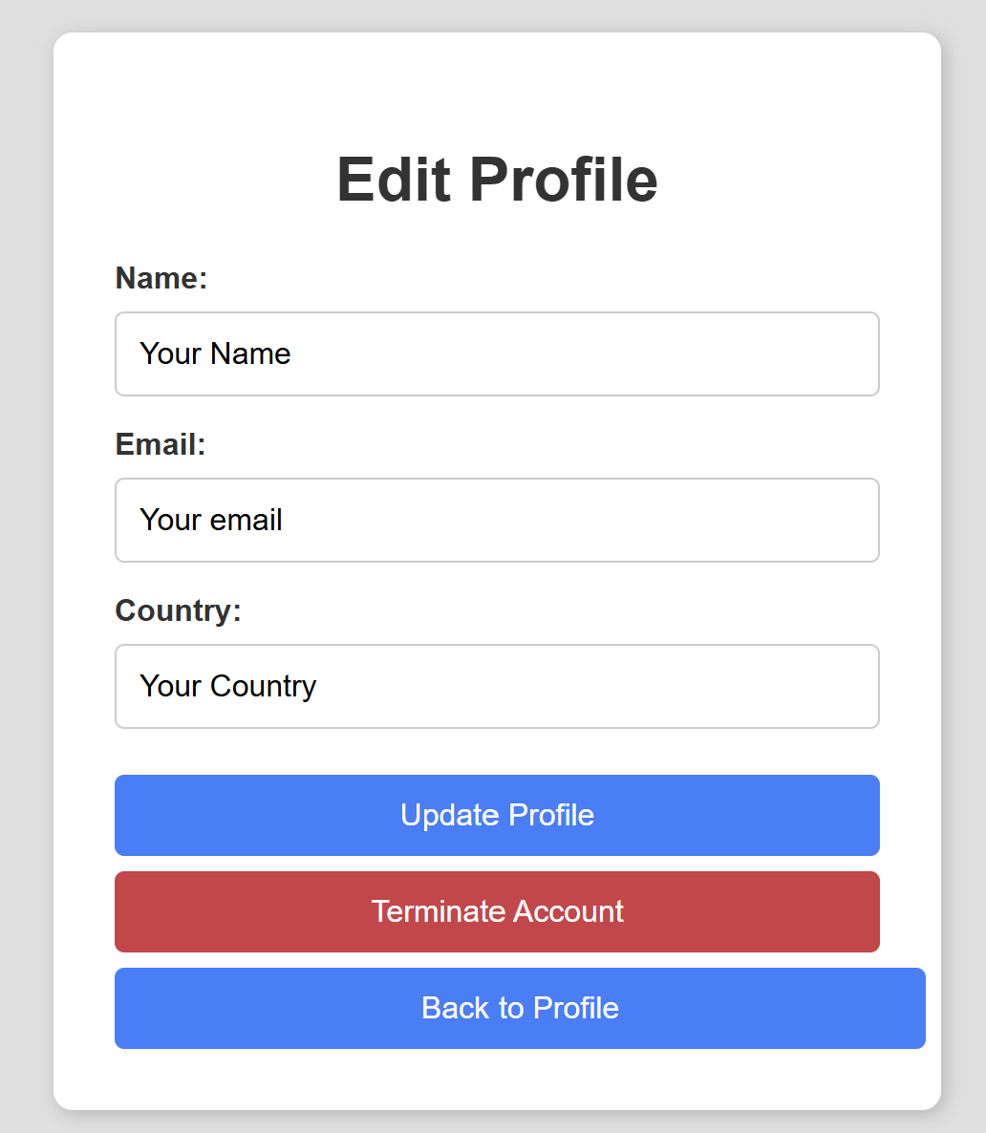
After you are done, click the “Update Profile” button and your details would now be saved.
- Errors:
  - Issue with updating email: Simply follow the prompt, emails must include the “@” symbol to be valid.
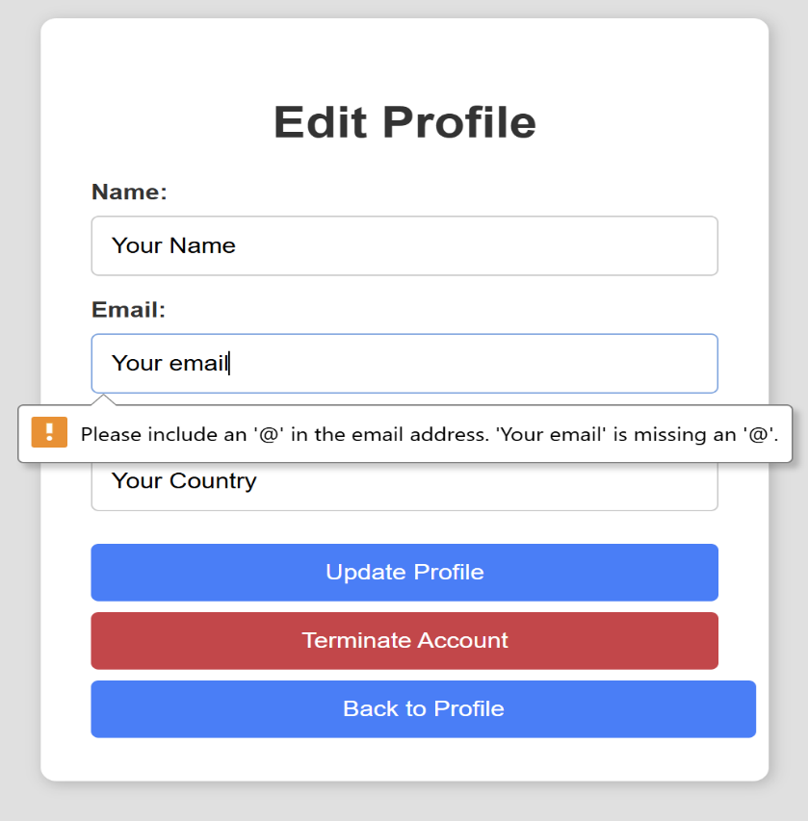

2.4) Deleting your profile:
After clicking the “Terminate Account” button you can delete the active profile.
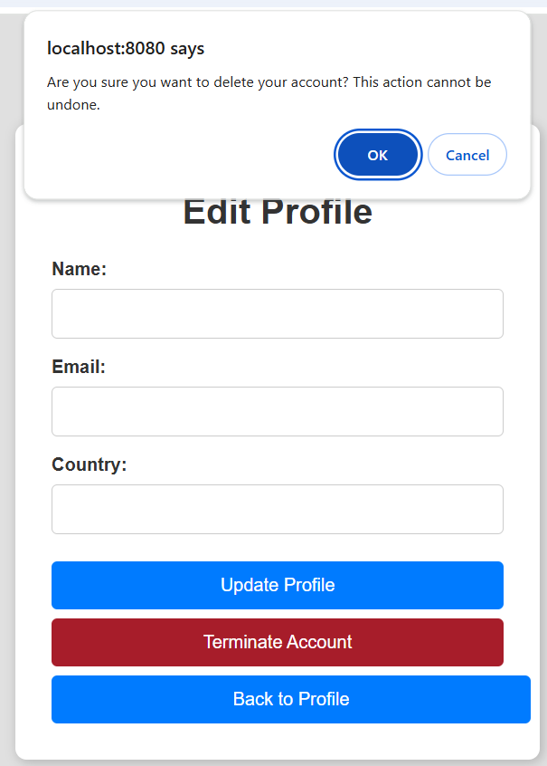
An alert asking the user to confirm their choice will appear

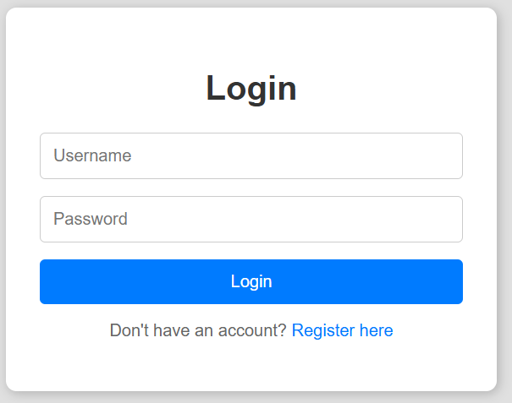
After pressing ok, the user is taken back to the login page

- Puzzles
  - How To:
3.1 Accessing the puzzle page: From the dashboard simply select the puzzle box.
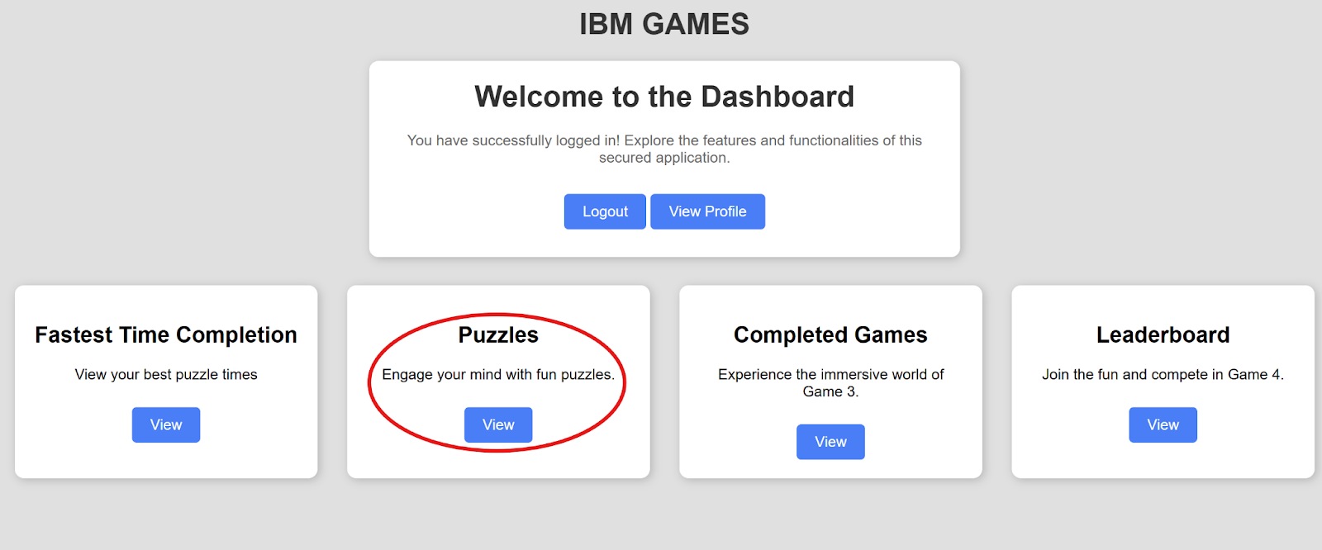

3.2 Choosing a puzzle: You will have the option to play easy, medium and hard puzzles.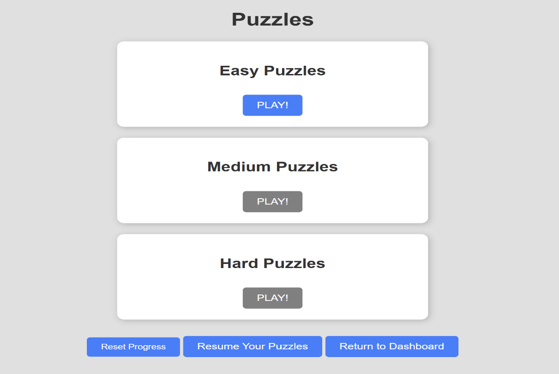 Click “PLAY!” to start.
3.3 Playing a puzzle: Puzzles are in the form of trivia questions, you are expected to type in the correct answer to the question in the box below. Note: answers are not case sensitive but adequate spacing should be provided. The click submit.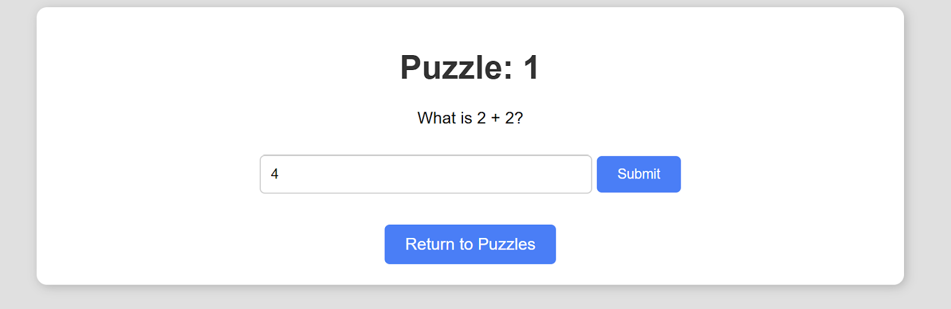You should see whether you answered the puzzle correctly or not.

4. Adaptive Learning Paths
- How To:
4.1) Access Puzzles: The users looking to complete some puzzles, will be first redirected to this html page, so far only the easy puzzles are available,and the rest are greyed out as the user progresses through the puzzles, more difficult puzzles will be unlocked.
4.2) Try Another Puzzle: Similarly, The users can complete puzzles without being on the puzzle page, but straight after their current one has been completed, using a similar feature if the easy puzzles hasn't been attempted, then the others will remain greyed out before completion

5. XP and Level System

5.1) Default XP and level: When the user logs in, every page will display the user on level 1 with an xp of 0.

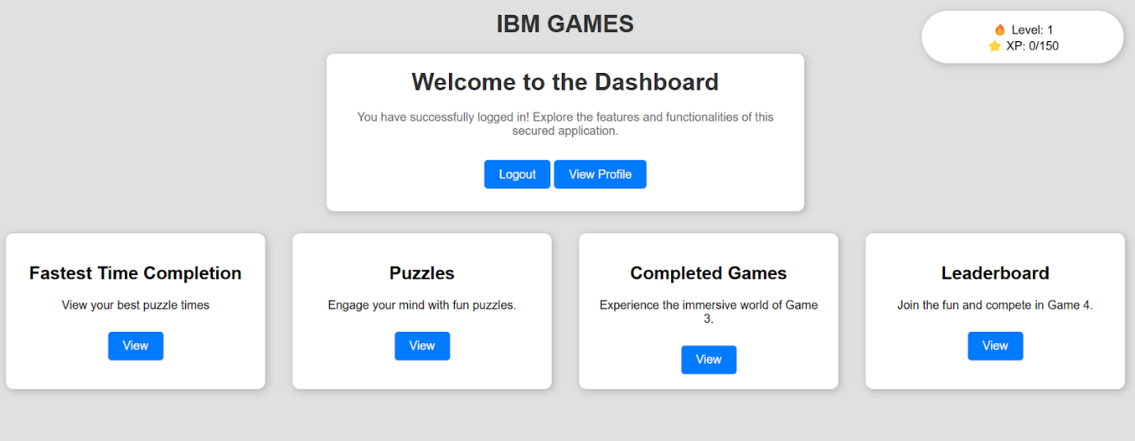

5.2) XP Increase: When the user completes a puzzle, the xp will update accordingly depending on difficulty (30 for easy puzzle, 60 for medium and 100 for hard)

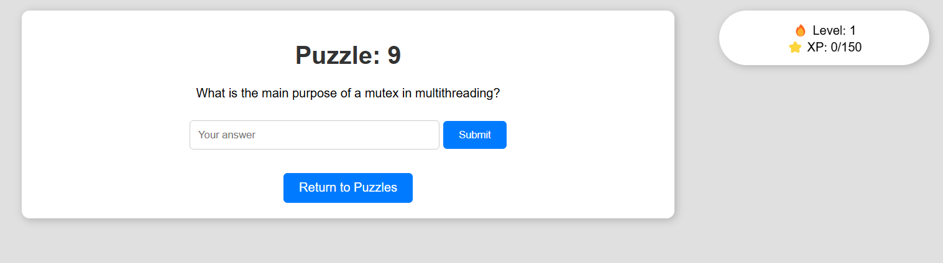
After answering hard question xp goes up by 100
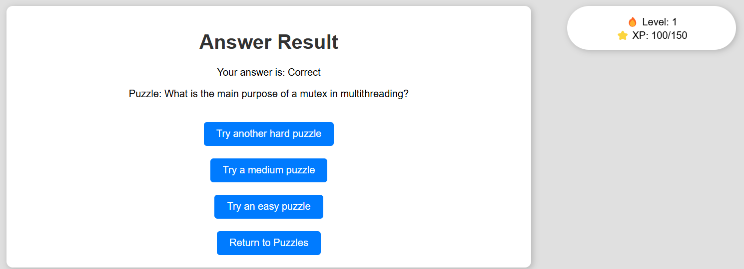

5.3) Level Increase: When the user completes a puzzle that puts them over the level threshold (150), the level will increase and the remaining xp will carry over to the next level


After answering a medium question xp increases by 60 and level subsequently increases
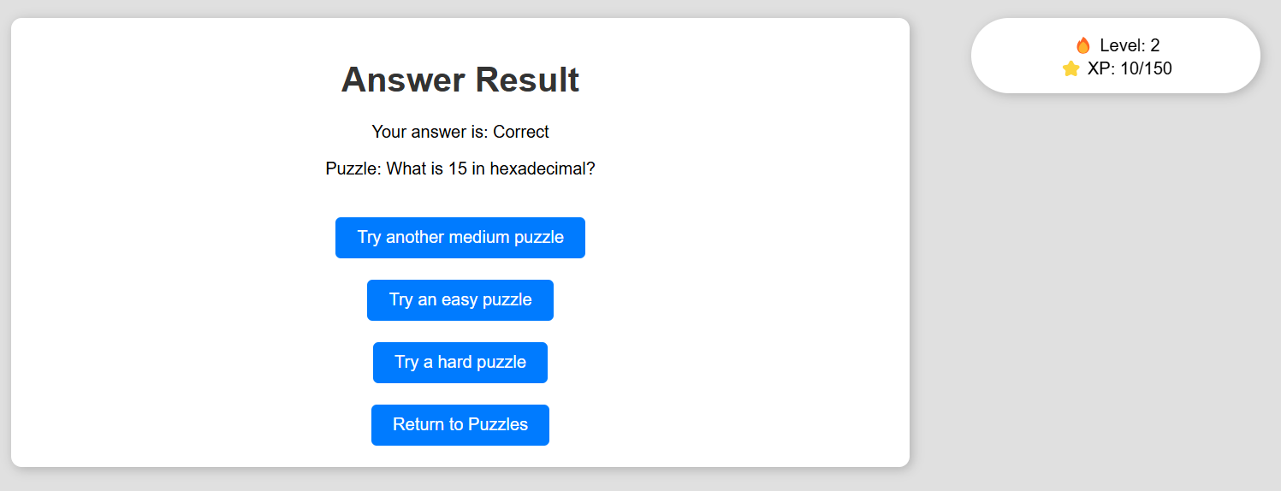

6. Save and Load Progress
How to:
6.1) Accessing Games completed: On the dashboard select View under Completed Games
6.2) Completed games table before playing puzzles: Before the user has played any quizzes the completed games table is empty, there’s no data from any previous user who has played the puzzles
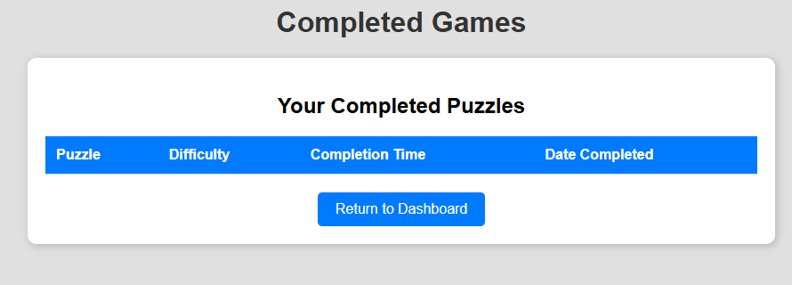
6.3) Completed games table after playing puzzles: Once the user starts playing puzzles each completed puzzle is saved and loaded on to the completed puzzles table including the time/date of completion
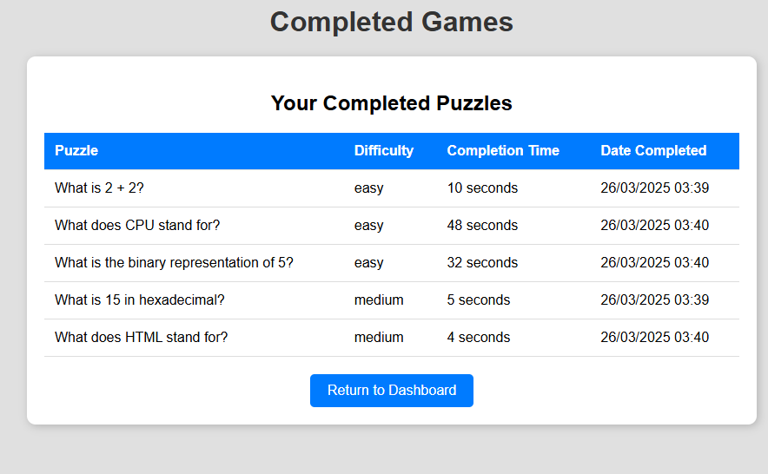

7. Record start and completion time
How to:
7.1 Accessing time completion table: On the dashboard select View under fastest time completion

7.2 Viewing time completion table: When the user has played multiple puzzles, they can see the recorded time it took them to solve the puzzle. The table displays this data in order from fastest completed puzzle to slowest. It also includes the puzzle question and difficulty.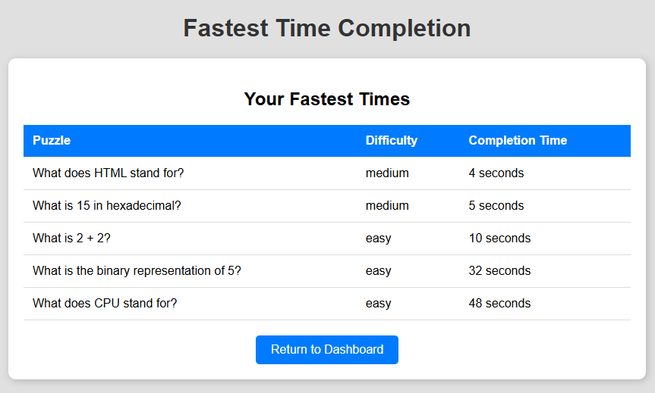
- Leaderboard
8.1 Accessing Leaderboard Page: On the dashboard select view under Leaderboard
8.2 Leaderboard with one user: When only one user has made an account and played a puzzle or more they will be able to see their Level, XP and number of puzzles they’ve completed
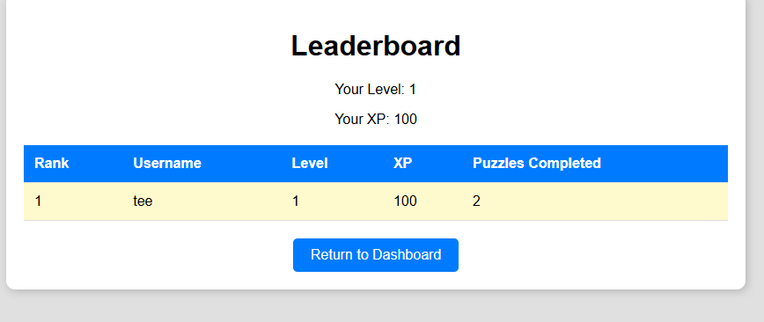
8.3 Leaderboard with more than one user: When more than one user has made an account the current user can see where they are on the rankings for levels/xp. The User that is currently logged into their account is highlighted so they can see their position clearly. The highest level ranks highest. Within each level the highest XP will be at a higher ranking than the others at the same level.
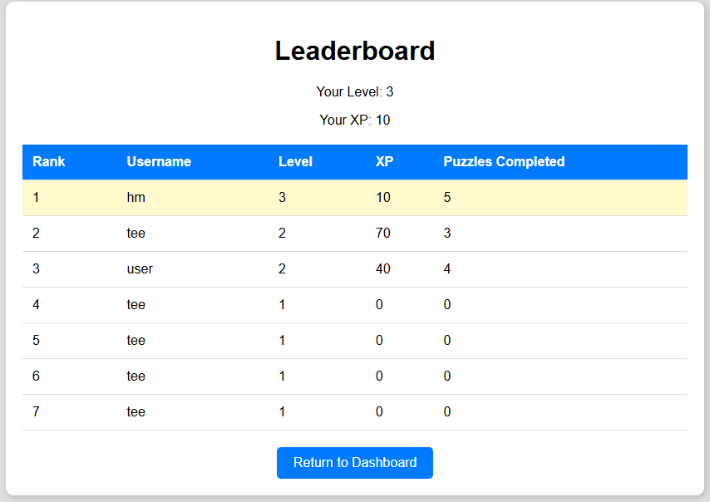

9. Search And Filter
9.1 Search bar: Use the search bar to find specific categories quickly by entering keywords.


9.2 Dropdown feature: Use the dropdown menu to view all available categories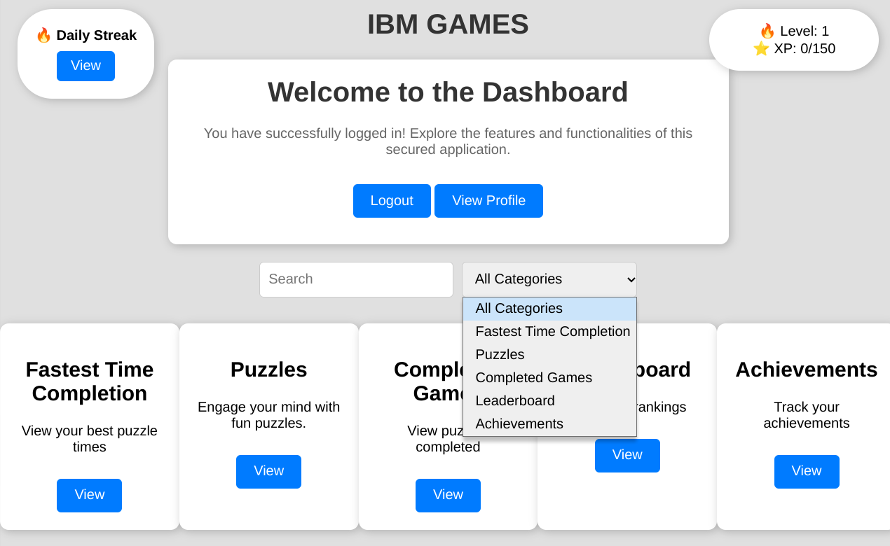

10. Achievements
10.1 Accessing Achievements Page
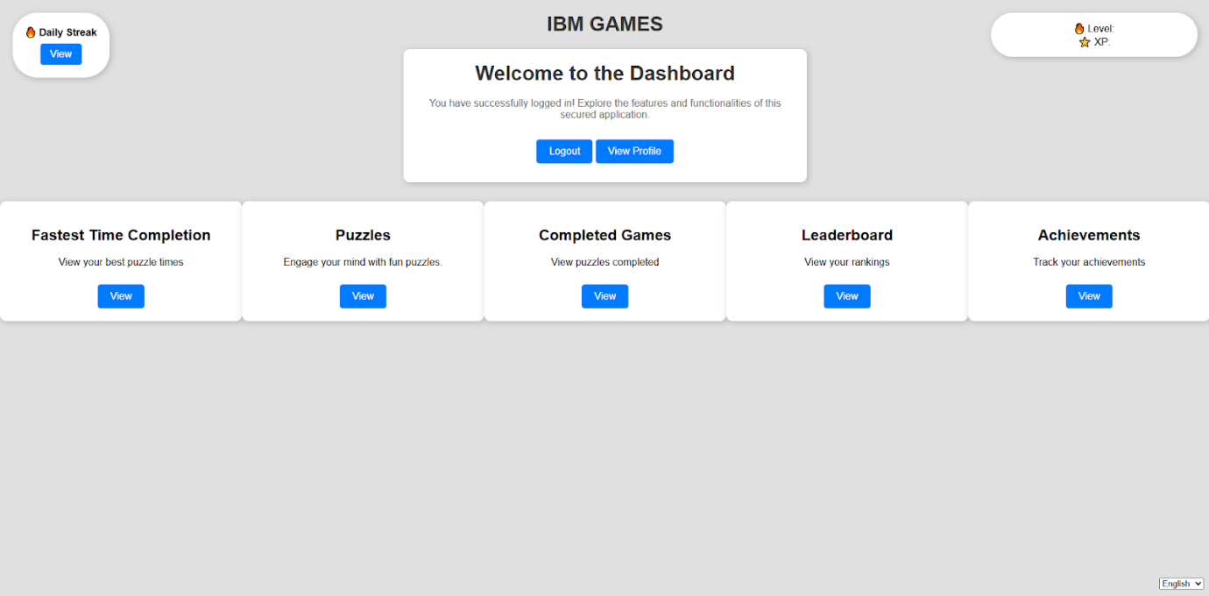
10.2 Viewing the Achievements table
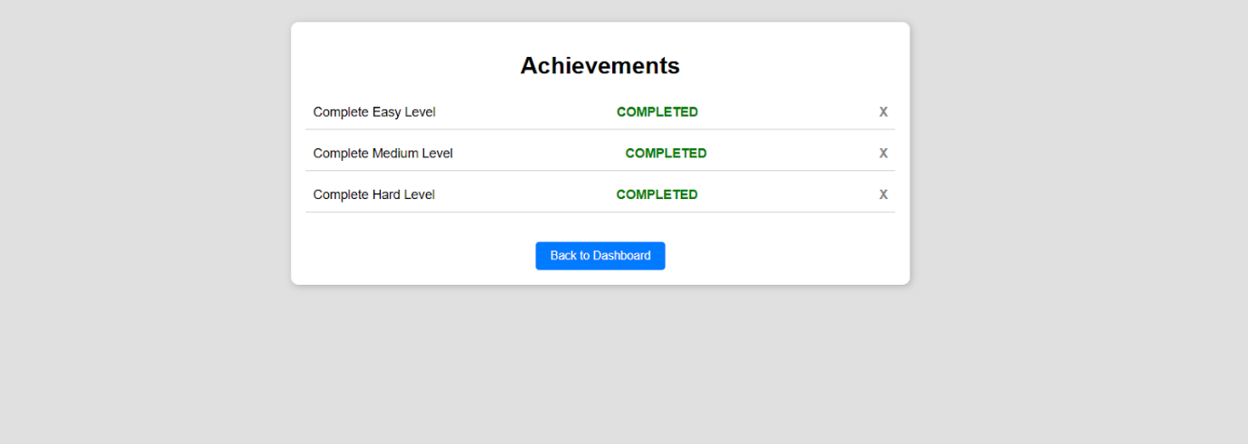

11.Change Languages
11.1 Accessing Languages Dropbox: Located on the bottom right of the screen. Displays on all landing pages. Shows the current language of the webpage

11.2 Dropdown Feature: Use the dropdown feature to view all available languages
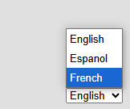

12. Daily Streak
12.1. View Daily Streak: Click the "View" button to open your Daily Streak and track your login progress.
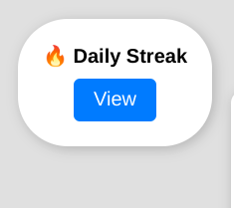

12.2: Claim XP: Click the "Claim XP" button to earn experience points based on your current streak count.
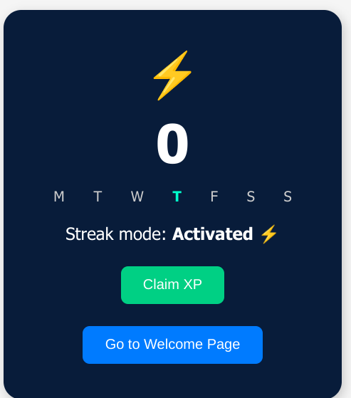

12.3 Return to Welcome Page: Click the "Go to Welcome Page" button to return to the main dashboard after claiming your XP.
